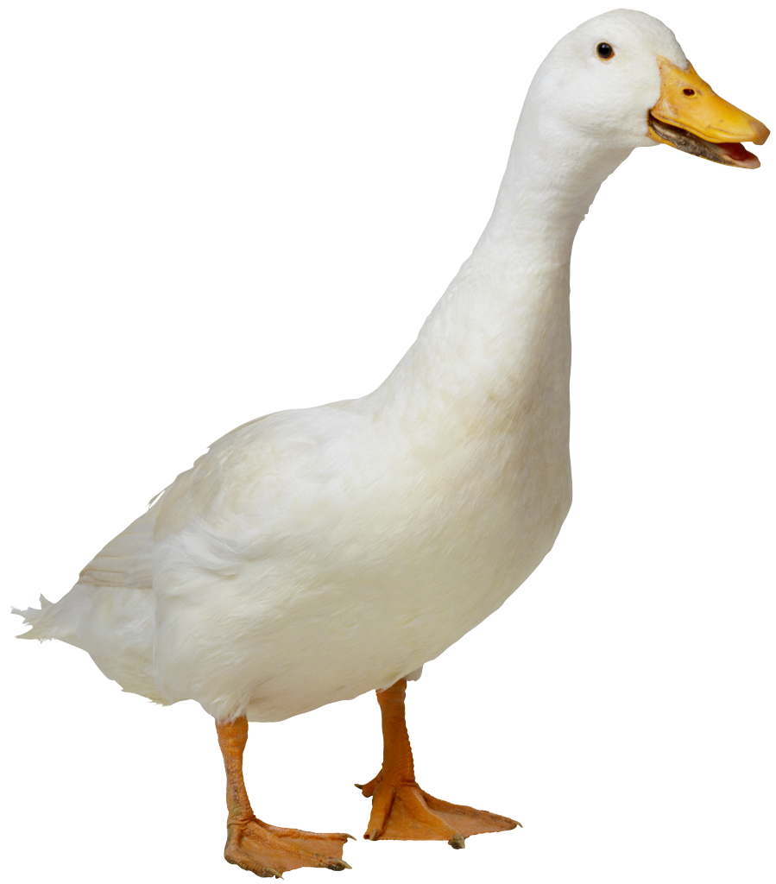Mrs. Kelsey & Mrs. Jerome Fruit List

**Please bring fresh fruit for 18 students for one snack on the Tuesday (unless otherwise noted) list below…**

|  |  |  |
| --- | --- | --- |
| ***ADELFIO*** | ***Teo*** | ***10/1*** |
| ***BREECE*** | ***George*** | ***10/8*** |
| ***BROWNSTEIN*** | ***Seth*** | ***10/15*** |
| ***DALY*** | ***Freya*** | ***10/22*** |
| ***DORAISWAMY*** | ***Elise*** | ***10/29*** |
| ***GACHOU*** | ***Gemma*** | ***11/5*** |
| ***GOONERATNE*** | ***Siddharth*** | ***11/12*** |
| ***HABERMAN*** | ***Julia*** | ***11/19*** |
| ***HANATA*** | ***Akari*** | ***11/26*** |
| ***KELLEY*** | ***Luke*** | ***12/3*** |
| ***MARKEY*** | ***Nicholas*** | ***12/10*** |
| ***MEHTA*** | ***Masai*** | ***1/7*** |
| ***RAY*** | ***Shayan*** | ***1/14*** |
| ***RHYMER*** | ***Frances*** | ***1/21*** |
| ***SINGH*** | ***Amara*** | ***1/28*** |
| ***SUKHATME*** | ***Anya*** | ***2/4*** |
| ***TIMBERLAKE*** | ***Yara*** | ***2/11*** |
| ***TOKUYOSHI*** | ***Luka*** | ***2/19 (WED)*** |
| ***VO*** | ***Leila*** | ***2/25*** |
| ***ADELFIO*** | ***Teo*** | ***3/04*** |
| ***BREECE*** | ***George*** | ***3/11*** |
| ***BROWNSTEIN*** | ***Seth*** | ***3/18*** |
| ***DALY*** | ***Freya*** | ***3/25*** |
| ***DORAISWAMY*** | ***Elise*** | ***4/1*** |
| ***GACHOU*** | ***Gemma*** | ***4/8*** |
| ***GOONERATNE*** | ***Siddharth*** | ***4/22*** |
| ***HABERMAN*** | ***Julia*** | ***4/29*** |
| ***HANATA*** | ***Akari*** | ***5/6*** |
| ***KELLEY*** | ***Luke*** | ***5/13*** |
| ***MARKEY*** | ***Nicholas*** | ***5/20*** |

Suggestions: pre-cut fruit tray, pre-cut honey dew or cantalope, whole bananas (9 or more depending on size), apples (9 or more depending on size), clementines (20 if small, 12 if large), pre-washed grapes or berries.