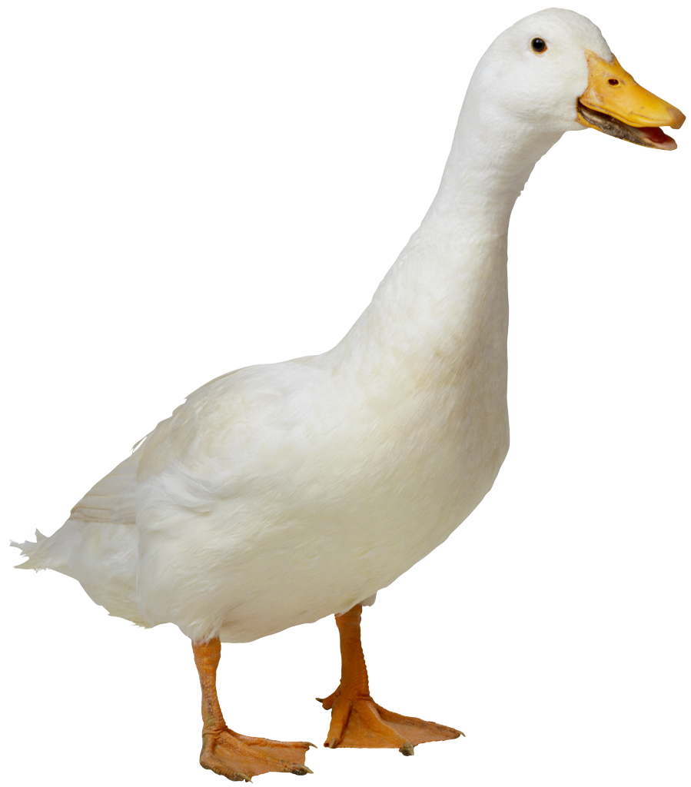**Mrs. Nicolardi, Mrs. Weaver, & Mrs. Mills**

**Please bring fresh fruit for 26 students for one snack on the Tuesday (unless otherwise noted) list below…**

|  |  |  |
| --- | --- | --- |
| ***AHMED*** | ***Kamil*** | ***10/1*** |
| ***BAUER*** | ***Dahlia*** | ***10/8*** |
| ***BOROD*** | ***Ayla*** | ***10/15*** |
| ***BRAZAUSKAS*** | ***Alice*** | ***10/22*** |
| ***CHUNG*** | ***Ruth*** | ***10/29*** |
| ***CLARK*** | ***Bonk*** | ***11/5*** |
| ***COLES*** | ***Solomon*** | ***11/12*** |
| ***DORAISWAMY*** | ***Levi*** | ***11/19*** |
| ***DORAN*** | ***Lev*** | ***11/26*** |
| ***DREYER*** | ***Ethan*** | ***12/3*** |
| ***FRIEDLAND*** | ***Theodore*** | ***12/10*** |
| ***FUCHIGAMI*** | ***Koh*** | ***1/7*** |
| ***GOTO*** | ***Kai*** | ***1/14*** |
| ***KASHIPOUR*** | ***Sara*** | ***1/21*** |
| ***KHAN*** | ***Anya*** | ***1/28*** |
| ***KIM*** | ***Ellis*** | ***2/4*** |
| ***MALAK*** | ***Mark*** | ***2/11*** |
| ***MOBASSER MORREN*** | ***Leia*** | ***2/19 (WED)*** |
| ***OZMEN*** | ***Defne*** | ***2/25*** |
| ***PILEGGI*** | ***Emile*** | ***3/04*** |
| ***RYCHLIK-PASSETO*** | ***MayaBella*** | ***3/11*** |
| ***STEIN*** | ***Lilia*** | ***3/18*** |
| ***TADDESE*** | ***Dagmawit*** | ***3/25*** |
| ***THOMAS*** | ***Elin*** | ***4/1*** |
| ***VERSTRAET*** | ***Alena*** | ***4/8*** |
| ***VOGEL*** | ***Brody*** | ***4/22*** |
| ***AHMED*** | ***Kamil*** | ***4/29*** |
| ***BAUER*** | ***Dahlia*** | ***5/6*** |
| ***BOROD*** | ***Ayla*** | ***5/13*** |
| ***BRAZAUSKAS*** | ***Alice*** | ***5/20*** |

Suggestions: pre-cut fruit tray, pre-cut honey dew or cantalope, whole bananas (12 or more depending on size), whole apples (12 or more depending on size), whole clementines (30 if small, 15 if large), pre-washed grapes or berries.